**Experiment No. 6**

**Aim:**  To implement 2D Transformations: Translation, Scaling, Rotation.

**Objective:**

To understand the concept of transformation, identify the process of transformation and application of these methods to different object and noting the difference between these transformations.

**Theory:**

**1) Translation –**

Translation is defined as moving the object from one position to another position along straight line path. We can move the objects based on translation distances along x and y axis. tx denotes translation distance along x-axis and ty denotes translation distance along y axis.

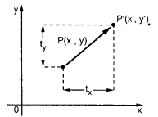

Consider (x,y) are old coordinates of a point. Then the new coordinates of that same point (x’,y’) can be obtained as follows:

**x’ = x + tx**

**y’ = y + ty**

We denote translation transformation as P. we express above equations in matrix form as:P’ = P + T , where

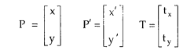

**Program:**

#include<stdio.h>

#include<conio.h>

#include<graphics.h>

#include<math.h>

void main()

{

int gd=DETECT,gm;

int x1,y1,x2,y2,tx,ty,x3,y3,x4,y4;

initgraph(&gd,&gm,"C:\\TurboC3\\BGI");

printf("Enter the starting point of line segment:");

scanf("%d %d",&x1,&y1);

printf("Enter the ending point of line segment:");

scanf("%d %d",&x2,&y2);

printf("Enter translation distances tx,ty:\n");

scanf("%d%d",&tx,&ty);

setcolor(5);

line(x1,y1,x2,y2);

outtextxy(x2+2,y2+2,"Original line");

x3=x1+tx;

y3=y1+ty;

x4=x2+tx;

y4=y2+ty;

setcolor(7);

line(x3,y3,x4,y4);

outtextxy(x4+2,y4+2,"Line after translation");

getch();

}

**Output –**

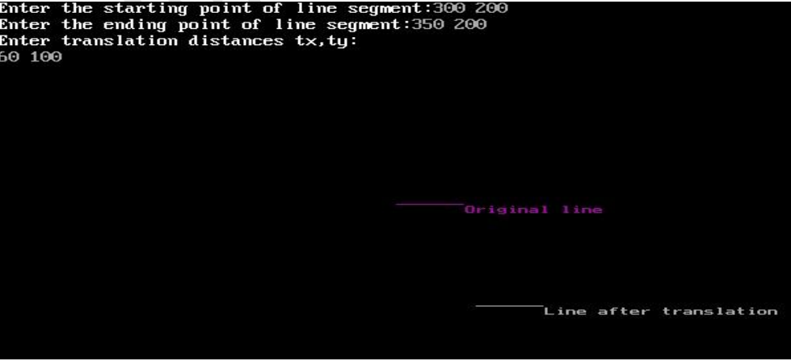

**2) Rotation –**

A rotation repositions all points in an object along a circular path in the plane centered at the

pivot point. We rotate an object by an angle theta. New coordinates after rotation depend on both x and y.

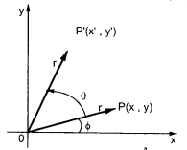



The above equations can be represented in the matrix form as given below

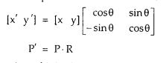

where R is the rotation matrix and it is given as



Program:

#include<stdio.h>

#include<conio.h>

#include<graphics.h>

#include<math.h>

void main()

{

int gd=DETECT,gm;

float x1,y1,x2,y2,x3,y3,x4,y4,a,t;

initgraph(&gd,&gm,"C:\\TurboC3\\BGI");

printf("Enter coordinates of starting point:\n");

scanf("%f%f",&x1,&y1);

printf("Enter coordinates of ending point\n");

scanf("%f%f",&x2,&y2);

printf("Enter angle for rotation\n");

scanf("%f",&a);

setcolor(5);

line(x1,y1,x2,y2);

outtextxy(x2+2,y2+2,"Original line");

t=a*(3.14/180);

x3=(x1*cos(t))-(y1*sin(t));

y3=(x1*sin(t))+(y1*cos(t));

x4=(x2*cos(t))-(y2*sin(t));

y4=(x2*sin(t))+(y2*cos(t));

setcolor(7);

line(x3,y3,x4,y4);

outtextxy(x3+2,y3+2,"Line after rotation");

getch();

**Output:**

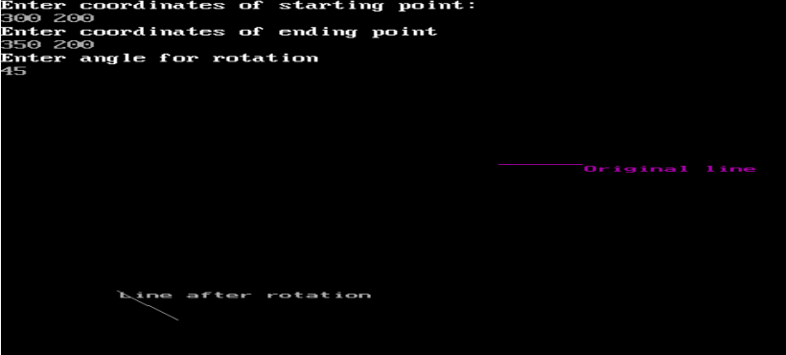

**3) Scaling -**

scaling refers to changing the size of the object either by increasing or decreasing. We will

increase or decrease the size of the object based on scaling factors along x and y-axis.

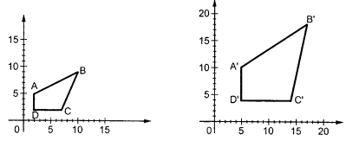

If (x, y) are old coordinates of object, then new coordinates of object after applying scaling

transformation are obtained as:

x’ = x * Sx

y’ = y * Sy

Sx and Sy are scaling factors along x-axis and y-axis. we express the above equations in matrix form as:

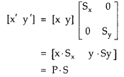

**Program:**

#include<stdio.h>

#include<conio.h>

#include<graphics.h>

#include<math.h>

void main()

{

int gd=DETECT,gm;

float x1,y1,x2,y2,sx,sy,x3,y3,x4,y4;

initgraph(&gd,&gm,"C:\\TurboC3\\BGI");

printf("Enter the starting point coordinates:");

scanf("%f %f",&x1,&y1);

printf("Enter the ending point coordinates:");

scanf("%f %f",&x2,&y2);

printf("Enter scaling factors sx,sy:\n");

scanf("%f%f",&sx,&sy);

setcolor(5);

line(x1,y1,x2,y2);

outtextxy(x2+2,y2+2,"Original line");

x3=x1*sx;

y3=y1*sy;

x4=x2*sx;

y4=y2*sy;

setcolor(7);

line(x3,y3,x4,y4);

outtextxy(x3+2,y3+2,"Line after scaling");

getch();

}

**Output –**

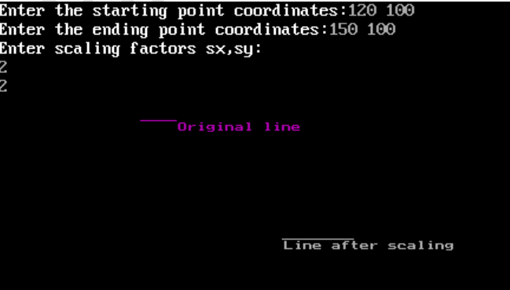

**Conclusion:**

Comment on :

1. Application of transformation
2. Difference noted between methods
3. Application on different object

Application of Transformation:

Transformations are fundamental concepts in computer graphics and geometry. They are used to manipulate objects in a coordinate system. The application of transformations allows for the repositioning, resizing, and reshaping of objects in a 2D or 3D space. These transformations are crucial in various fields, including computer animation, video game development, and image processing

Difference Noted between Translation, Rotation, Scaling:

Translation involves moving an object from one location to another without changing its orientation or size. It only affects the position of the object in the coordinate system. Rotation, on the other hand, involves turning an object around a fixed point, changing its orientation. It does not change the object's size or position, only its spatial orientation. Scaling refers to resizing an object either larger or smaller, without changing its shape. It affects the dimensions of the object but not its position or orientation.

Application of Translation, Rotation, Scaling on Different Objects:

Translation can be applied to various objects, such as moving a car along a road, shifting a text box on a computer screen, or relocating a character in a video game. Rotation finds application in scenarios like spinning a wheel, rotating a character in an animation, or tilting an object in a design. Scaling is used to change the size of objects, such as zooming in or out on an image, resizing a window on a computer screen, or adjusting the dimensions of a 3D model.